1. Create your first Android application to display Hello world(use any background image)
2. Use Text view, Edit text, Button and image view to design a Login UI. Try using Constraint Layout and Relative layout.

COMBINED

Design

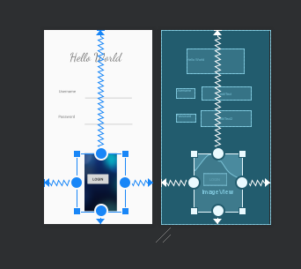

Main_Activity.xml

<?xml version="1.0" encoding="utf-8"?>  
<androidx.constraintlayout.widget.ConstraintLayout xmlns:android="http://schemas.android.com/apk/res/android"  
 xmlns:app="http://schemas.android.com/apk/res-auto"  
 xmlns:tools="http://schemas.android.com/tools"  
 android:layout_width="match_parent"  
 android:layout_height="match_parent"  
 tools:context=".MainActivity">  
  
 <TextView  
 android:id="@+id/usernameLabel"  
 android:layout_width="71dp"  
 android:layout_height="35dp"  
 android:layout_marginStart="56dp"  
 android:text="Username"  
 app:layout_constraintBottom_toBottomOf="parent"  
 app:layout_constraintHorizontal_bias="0.227"  
 app:layout_constraintLeft_toLeftOf="parent"  
 app:layout_constraintRight_toRightOf="parent"  
 app:layout_constraintStart_toStartOf="parent"  
 app:layout_constraintTop_toTopOf="parent"  
 app:layout_constraintVertical_bias="0.318" />  
  
 <EditText  
 android:id="@+id/editText"  
 android:layout_width="186dp"  
 android:layout_height="51dp"  
 android:ems="10"  
 android:inputType="textPersonName"  
 app:layout_constraintBottom_toBottomOf="parent"  
 app:layout_constraintEnd_toEndOf="parent"  
 app:layout_constraintHorizontal_bias="0.675"  
 app:layout_constraintStart_toStartOf="parent"  
 app:layout_constraintTop_toTopOf="parent"  
 app:layout_constraintVertical_bias="0.314" />  
  
 <TextView  
 android:id="@+id/pwdLabel"  
 android:layout_width="72dp"  
 android:layout_height="31dp"  
 android:text="Password"  
 app:layout_constraintBottom_toBottomOf="parent"  
 app:layout_constraintEnd_toEndOf="parent"  
 app:layout_constraintHorizontal_bias="0.162"  
 app:layout_constraintStart_toStartOf="parent"  
 app:layout_constraintTop_toTopOf="parent"  
 app:layout_constraintVertical_bias="0.452" />  
  
 <EditText  
 android:id="@+id/editText2"  
 android:layout_width="189dp"  
 android:layout_height="61dp"  
 android:ems="10"  
 android:inputType="textPersonName"  
 app:layout_constraintBottom_toBottomOf="parent"  
 app:layout_constraintEnd_toEndOf="parent"  
 app:layout_constraintHorizontal_bias="0.678"  
 app:layout_constraintStart_toStartOf="parent"  
 app:layout_constraintTop_toTopOf="parent"  
 app:layout_constraintVertical_bias="0.452" />  
  
 <Button  
 android:id="@+id/login"  
 android:layout_width="wrap_content"  
 android:layout_height="wrap_content"  
 android:text="Login"  
 app:layout_constraintBottom_toBottomOf="parent"  
 app:layout_constraintEnd_toEndOf="parent"  
 app:layout_constraintHorizontal_bias="0.498"  
 app:layout_constraintStart_toStartOf="parent"  
 app:layout_constraintTop_toTopOf="parent"  
 app:layout_constraintVertical_bias="0.787" />  
  
 <ImageView  
 android:id="@+id/simpleImageView"  
 android:layout_width="184dp"  
 android:layout_height="218dp"  
 android:src="@drawable/blue"  
 app:layout_constraintBottom_toBottomOf="parent"  
 app:layout_constraintEnd_toEndOf="parent"  
 app:layout_constraintHorizontal_bias="0.542"  
 app:layout_constraintStart_toStartOf="parent"  
 app:layout_constraintTop_toTopOf="parent"  
 app:layout_constraintVertical_bias="0.905" />  
  
 <TextView  
 android:id="@+id/textView2"  
 android:layout_width="216dp"  
 android:layout_height="92dp"  
 android:fontFamily="cursive"  
 android:foregroundTint="#FF5722"  
 android:textAppearance="@style/TextAppearance.AppCompat.Display2"  
 app:layout_constraintBottom_toBottomOf="parent"  
 app:layout_constraintEnd_toEndOf="parent"  
 app:layout_constraintHorizontal_bias="0.497"  
 app:layout_constraintStart_toStartOf="parent"  
 app:layout_constraintTop_toTopOf="parent"  
 app:layout_constraintVertical_bias="0.109"  
 tools:text="Hello World" />  
  
</androidx.constraintlayout.widget.ConstraintLayout>

MainActivity.java

package com.example.helloworld;  
  
import androidx.appcompat.app.AppCompatActivity;  
  
import android.os.Bundle;  
import android.widget.Toast;  
import android.widget.Button;  
import android.view.View;  
  
public class MainActivity extends AppCompatActivity {  
  
 Button login;  
 @Override  
 protected void onCreate(Bundle savedInstanceState) {  
 super.onCreate(savedInstanceState);  
 setContentView(R.layout.*activity_main*);  
 login = (Button) findViewById(R.id.*login*);  
 login.setOnClickListener(new View.OnClickListener() {  
 public void onClick(View view) {  
 Toast.*makeText*(getApplicationContext(), "Hey", Toast.*LENGTH_LONG*).show();//display the text of button1  
 }  
 });  
 }  
}

Output

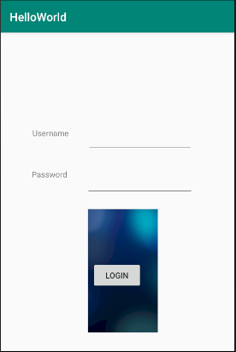

3. Use Toast to display the message on a button click.

Source Code

MainActivity.java

package com.example.toast;  
  
import androidx.appcompat.app.AppCompatActivity;  
  
import android.graphics.Color;  
import android.os.Bundle;  
import android.view.View;  
import android.widget.Button;  
import android.widget.Toast;  
  
public class MainActivity extends AppCompatActivity {  
  
 @Override  
 protected void onCreate(Bundle savedInstanceState) {  
 super.onCreate(savedInstanceState);  
 setContentView(R.layout.*activity_main*);  
  
 Button simpleButton=(Button) findViewById(R.id.*button1*);  
 simpleButton.setTextSize(25);  
 simpleButton.setTextColor(Color.*RED*);//set the red color for the text  
  
 simpleButton.setOnClickListener(new View.OnClickListener() {  
 @Override  
 public void onClick(View view) {  
 Toast.*makeText*(getApplicationContext(), "Hey", Toast.*LENGTH_LONG*).show();//display the text of button1  
 }  
 });  
 }  
}

Main_Activity.xml

<?xml version="1.0" encoding="utf-8"?>  
<androidx.constraintlayout.widget.ConstraintLayout xmlns:android="http://schemas.android.com/apk/res/android"  
 xmlns:app="http://schemas.android.com/apk/res-auto"  
 xmlns:tools="http://schemas.android.com/tools"  
 android:layout_width="match_parent"  
 android:layout_height="match_parent"  
 tools:context=".MainActivity">  
  
 <TextView  
 android:id="@+id/textView"  
 android:layout_width="wrap_content"  
 android:layout_height="wrap_content"  
 android:text="Hello World!"  
 app:layout_constraintBottom_toBottomOf="parent"  
 app:layout_constraintHorizontal_bias="0.461"  
 app:layout_constraintLeft_toLeftOf="parent"  
 app:layout_constraintRight_toRightOf="parent"  
 app:layout_constraintTop_toTopOf="parent"  
 app:layout_constraintVertical_bias="0.459" />  
  
 <Button  
 android:id="@+id/button1"  
 android:layout_width="wrap_content"  
 android:layout_height="wrap_content"  
 android:text="Button"  
 app:layout_constraintBottom_toBottomOf="parent"  
 app:layout_constraintEnd_toEndOf="parent"  
 app:layout_constraintHorizontal_bias="0.498"  
 app:layout_constraintStart_toStartOf="parent"  
 app:layout_constraintTop_toTopOf="parent"  
 app:layout_constraintVertical_bias="0.595" />  
  
</androidx.constraintlayout.widget.ConstraintLayout>

Output

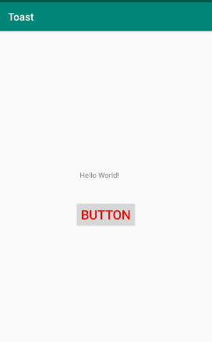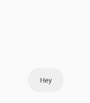

4. Try out Check box and Radio button and create a Quiz App with minimal Interface. Quiz app needs to have 3 questions and its different choices using check box for multiple answers and radio button for single answer. On submitting the answers, the app should display the total score. Also the user’s response needs to be validated and must display the correct answers using a Green tick mark.

**Design**

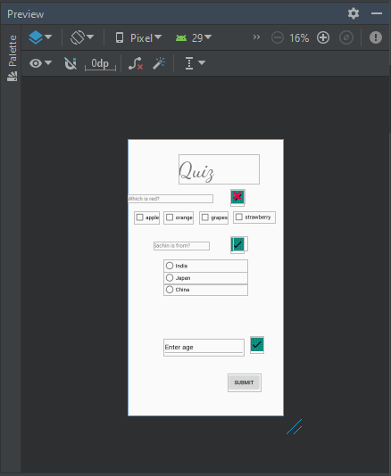

**Source Code**

Main_Activity.xml

<?xml version="1.0" encoding="utf-8"?>  
<androidx.constraintlayout.widget.ConstraintLayout xmlns:android="http://schemas.android.com/apk/res/android"  
 xmlns:app="http://schemas.android.com/apk/res-auto"  
 xmlns:tools="http://schemas.android.com/tools"  
 android:layout_width="match_parent"  
 android:layout_height="match_parent"  
 tools:context=".MainActivity">  
  
 <ImageView  
 android:id="@+id/imageView5"  
 android:layout_width="36dp"  
 android:layout_height="45dp"  
 app:layout_constraintBottom_toBottomOf="parent"  
 app:layout_constraintEnd_toEndOf="parent"  
 app:layout_constraintHorizontal_bias="0.864"  
 app:layout_constraintStart_toStartOf="parent"  
 app:layout_constraintTop_toTopOf="parent"  
 app:layout_constraintVertical_bias="0.759"  
 app:srcCompat="@mipmap/tick_round" />  
  
 <ImageView  
 android:id="@+id/imageView3"  
 android:layout_width="37dp"  
 android:layout_height="37dp"  
 app:layout_constraintBottom_toBottomOf="parent"  
 app:layout_constraintEnd_toEndOf="parent"  
 app:layout_constraintHorizontal_bias="0.745"  
 app:layout_constraintStart_toStartOf="parent"  
 app:layout_constraintTop_toTopOf="parent"  
 app:layout_constraintVertical_bias="0.37"

app:srcCompat="@android:drawable/ic_delete" />  
  
 <TextView  
 android:id="@+id/textView"  
 android:layout_width="212dp"  
 android:layout_height="79dp"  
 android:fontFamily="cursive"  
 android:text="Quiz"  
 android:textAppearance="@style/TextAppearance.AppCompat.Display3"  
 app:layout_constraintBottom_toBottomOf="parent"  
 app:layout_constraintHorizontal_bias="0.673"  
 app:layout_constraintLeft_toLeftOf="parent"  
 app:layout_constraintRight_toRightOf="parent"  
 app:layout_constraintTop_toTopOf="parent"  
 app:layout_constraintVertical_bias="0.062" />  
  
 <CheckBox  
 android:id="@+id/checkBox"  
 android:layout_width="wrap_content"  
 android:layout_height="wrap_content"  
 android:text="apple"  
 app:layout_constraintBottom_toBottomOf="parent"  
 app:layout_constraintEnd_toEndOf="parent"  
 app:layout_constraintHorizontal_bias="0.046"  
 app:layout_constraintStart_toStartOf="parent"  
 app:layout_constraintTop_toTopOf="parent"  
 app:layout_constraintVertical_bias="0.273" />  
  
 <CheckBox  
 android:id="@+id/checkBox2"  
 android:layout_width="wrap_content"  
 android:layout_height="wrap_content"  
 android:text="orange"  
 app:layout_constraintBottom_toBottomOf="parent"  
 app:layout_constraintEnd_toEndOf="parent"  
 app:layout_constraintHorizontal_bias="0.284"  
 app:layout_constraintStart_toStartOf="parent"  
 app:layout_constraintTop_toTopOf="parent"  
 app:layout_constraintVertical_bias="0.273" />  
  
 <CheckBox  
 android:id="@+id/checkBox3"  
 android:layout_width="wrap_content"  
 android:layout_height="wrap_content"  
 android:text="grapes"  
 app:layout_constraintBottom_toBottomOf="parent"  
 app:layout_constraintEnd_toEndOf="parent"  
 app:layout_constraintHorizontal_bias="0.562"  
 app:layout_constraintStart_toStartOf="parent"  
 app:layout_constraintTop_toTopOf="parent"  
 app:layout_constraintVertical_bias="0.273" />  
  
 <CheckBox  
 android:id="@+id/checkBox4"  
 android:layout_width="110dp"  
 android:layout_height="30dp"  
 android:text="strawberry"  
 app:layout_constraintBottom_toBottomOf="parent"  
 app:layout_constraintEnd_toEndOf="parent"  
 app:layout_constraintHorizontal_bias="0.926"  
 app:layout_constraintStart_toStartOf="parent"  
 app:layout_constraintTop_toTopOf="parent"  
 app:layout_constraintVertical_bias="0.272" />  
  
 <TextView  
 android:id="@+id/textView2"  
 android:layout_width="225dp"  
 android:layout_height="22dp"  
 android:text="Which is red?"  
 app:layout_constraintBottom_toBottomOf="parent"  
 app:layout_constraintEnd_toEndOf="parent"  
 app:layout_constraintHorizontal_bias="0.0"  
 app:layout_constraintStart_toStartOf="parent"  
 app:layout_constraintTop_toTopOf="parent"  
 app:layout_constraintVertical_bias="0.208" />  
  
 <RadioGroup  
 android:id="@+id/radioGroup"  
 android:layout_width="221dp"  
 android:layout_height="94dp"  
 app:layout_constraintBottom_toBottomOf="parent"  
 app:layout_constraintEnd_toEndOf="parent"  
 app:layout_constraintStart_toStartOf="parent"  
 app:layout_constraintTop_toTopOf="parent">  
  
 <RadioButton  
 android:id="@+id/radioButton"  
 android:layout_width="match_parent"  
 android:layout_height="wrap_content"  
 android:text="India" />  
  
 <RadioButton  
 android:id="@+id/radioButton2"  
 android:layout_width="match_parent"  
 android:layout_height="wrap_content"  
 android:text="Japan" />  
  
 <RadioButton  
 android:id="@+id/radioButton3"  
 android:layout_width="match_parent"  
 android:layout_height="wrap_content"  
 android:text="China" />  
 </RadioGroup>  
  
 <TextView  
 android:id="@+id/textView3"  
 android:layout_width="145dp"  
 android:layout_height="22dp"  
 android:text="Sachin is from?"  
 app:layout_constraintBottom_toBottomOf="parent"  
 app:layout_constraintEnd_toEndOf="parent"  
 app:layout_constraintHorizontal_bias="0.255"  
 app:layout_constraintStart_toStartOf="parent"  
 app:layout_constraintTop_toTopOf="parent"  
 app:layout_constraintVertical_bias="0.383" />  
  
 <EditText  
 android:id="@+id/editText"  
 android:layout_width="wrap_content"  
 android:layout_height="wrap_content"  
 android:layout_marginTop="528dp"  
 android:ems="10"  
 android:inputType="textPersonName"  
 android:text="Enter age"  
 app:layout_constraintBottom_toBottomOf="parent"  
 app:layout_constraintEnd_toEndOf="parent"  
 app:layout_constraintHorizontal_bias="0.479"  
 app:layout_constraintStart_toStartOf="parent"  
 app:layout_constraintTop_toTopOf="parent"  
 app:layout_constraintVertical_bias="0.0" />  
  
 <Button  
 android:id="@+id/button"  
 android:layout_width="wrap_content"  
 android:layout_height="wrap_content"  
 android:text="Submit"  
 app:layout_constraintBottom_toBottomOf="parent"  
 app:layout_constraintEnd_toEndOf="parent"  
 app:layout_constraintHorizontal_bias="0.817"  
 app:layout_constraintStart_toStartOf="parent"  
 app:layout_constraintTop_toTopOf="parent"  
 app:layout_constraintVertical_bias="0.907" />  
  
 <ImageView  
 android:id="@+id/imageView"  
 android:layout_width="36dp"  
 android:layout_height="45dp"  
 app:layout_constraintBottom_toBottomOf="parent"  
 app:layout_constraintEnd_toEndOf="parent"  
 app:layout_constraintHorizontal_bias="0.725"  
 app:layout_constraintStart_toStartOf="parent"  
 app:layout_constraintTop_toTopOf="parent"  
 app:layout_constraintVertical_bias="0.192"  
 app:srcCompat="@mipmap/tick_round" />  
  
 <ImageView  
 android:id="@+id/imageView4"  
 android:layout_width="36dp"  
 android:layout_height="45dp"  
 app:layout_constraintBottom_toBottomOf="parent"  
 app:layout_constraintEnd_toEndOf="parent"  
 app:layout_constraintHorizontal_bias="0.725"  
 app:layout_constraintStart_toStartOf="parent"  
 app:layout_constraintTop_toTopOf="parent"  
 app:layout_constraintVertical_bias="0.374"  
 app:srcCompat="@mipmap/tick_round" />  
  
 <ImageView  
 android:id="@+id/imageView2"  
 android:layout_width="37dp"  
 android:layout_height="37dp"  
 app:layout_constraintBottom_toBottomOf="parent"  
 app:layout_constraintEnd_toEndOf="parent"  
 app:layout_constraintHorizontal_bias="0.724"  
 app:layout_constraintStart_toStartOf="parent"  
 app:layout_constraintTop_toTopOf="parent"  
 app:layout_constraintVertical_bias="0.19"  
 app:srcCompat="@android:drawable/ic_delete" />  
  
</androidx.constraintlayout.widget.ConstraintLayout>

MainActivity.java

package com.example.quiz;  
  
import androidx.appcompat.app.AppCompatActivity;  
  
import android.graphics.Color;  
import android.view.View;  
import android.widget.Button;  
import android.widget.EditText;  
import android.widget.ImageView;  
import android.widget.RadioButton;  
import android.widget.Toast;  
import android.widget.CheckBox;  
  
import android.os.Bundle;  
  
import static android.view.View.*INVISIBLE*;  
  
public class MainActivity extends AppCompatActivity {  
  
 int score;  
 Button simpleButton1;  
 CheckBox apple, orange, grapes, strawberry, unity3D;  
 @Override  
 protected void onCreate(Bundle savedInstanceState) {  
 super.onCreate(savedInstanceState);  
 setContentView(R.layout.*activity_main*);  
 final ImageView correct = (ImageView)findViewById(R.id.*imageView*);  
 final ImageView wrong = (ImageView)findViewById(R.id.*imageView2*);  
  
 final ImageView correct2 = (ImageView)findViewById(R.id.*imageView4*);  
 final ImageView wrong2 = (ImageView)findViewById(R.id.*imageView3*);  
  
 final ImageView correct3 = (ImageView)findViewById(R.id.*imageView5*);  
 correct.setVisibility(*INVISIBLE*);  
 wrong.setVisibility(*INVISIBLE*);  
 correct2.setVisibility(*INVISIBLE*);  
 wrong2.setVisibility(*INVISIBLE*);  
 correct3.setVisibility(*INVISIBLE*);  
  
 apple = (CheckBox) findViewById(R.id.*checkBox*);  
// apple.setOnClickListener(this);  
 orange = (CheckBox) findViewById(R.id.*checkBox2*);  
// orange.setOnClickListener(this);  
 grapes = (CheckBox) findViewById(R.id.*checkBox3*);  
// grapes.setOnClickListener(this);  
 strawberry = (CheckBox) findViewById(R.id.*checkBox4*);  
// strawberry.setOnClickListener(this);  
 simpleButton1 = (Button) findViewById(R.id.*button*);  
  
 simpleButton1.setOnClickListener(new View.OnClickListener() {  
 public void onClick(View view) {  
  
 Toast.*makeText*(getApplicationContext(), "score:" +score, Toast.*LENGTH_LONG*).show();//display the text of button1  
 EditText simpleEditText = (EditText) findViewById(R.id.*editText*);  
 String editTextValue = simpleEditText.getText().toString();  
  
 if(apple.isChecked()){  
 score+=1;  
 apple.setTextColor(Color.*GREEN*);  
 wrong.setVisibility(View.*INVISIBLE*);  
 correct.setVisibility(View.*VISIBLE*);  
  
 }  
 if(orange.isChecked()){  
 orange.setTextColor(Color.*RED*);  
 correct.setVisibility(*INVISIBLE*);  
 wrong.setVisibility(View.*VISIBLE*);  
 }  
 if(grapes.isChecked())  
 {  
 grapes.setTextColor(Color.*RED*);  
 correct.setVisibility(*INVISIBLE*);  
 wrong.setVisibility(View.*VISIBLE*);  
 }  
 if(strawberry.isChecked()) {  
 strawberry.setTextColor(Color.*RED*);  
 correct.setVisibility(*INVISIBLE*);  
 wrong.setVisibility(View.*VISIBLE*);  
 }  
  
 RadioButton India = (RadioButton) findViewById(R.id.*radioButton*); // initiate a radio button  
 RadioButton Japan = (RadioButton) findViewById(R.id.*radioButton2*);  
 RadioButton China = (RadioButton) findViewById(R.id.*radioButton3*);  
  
  
  
 if(India.isChecked()){  
 India.setTextColor(Color.*GREEN*);  
 // check current state of a radio button (true or false).  
 wrong2.setVisibility(View.*INVISIBLE*);  
 correct2.setVisibility(View.*VISIBLE*);  
 }  
 if(Japan.isChecked()){  
 Japan.setTextColor(Color.*RED*);  
 correct2.setVisibility(*INVISIBLE*);  
 wrong2.setVisibility(View.*VISIBLE*);  
 }  
 if(China.isChecked()){  
 China.setTextColor(Color.*RED*);  
 correct2.setVisibility(*INVISIBLE*);  
 wrong2.setVisibility(View.*VISIBLE*);  
 }  
 correct3.setVisibility(View.*VISIBLE*);  
 }  
  
 });  
 }  
  
}

**Output**

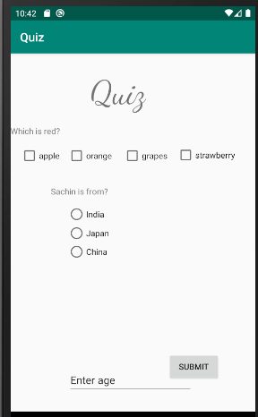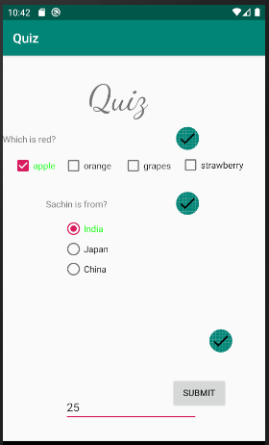

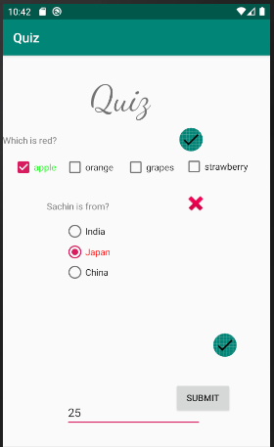

5. Use date picker, time picker and calendar view. Display the output in the same activity

Design

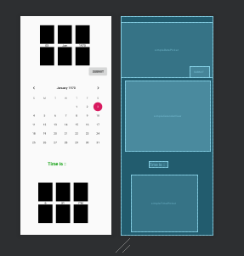

Source Code

Main_Activity.xml

<?xml version="1.0" encoding="utf-8"?>  
<androidx.constraintlayout.widget.ConstraintLayout xmlns:android="http://schemas.android.com/apk/res/android"  
 xmlns:app="http://schemas.android.com/apk/res-auto"  
 xmlns:tools="http://schemas.android.com/tools"  
 android:layout_width="match_parent"  
 android:layout_height="match_parent"  
 tools:context=".MainActivity">  
  
 <DatePicker  
 android:id="@+id/simpleDatePicker"  
 android:layout_width="408dp"  
 android:layout_height="246dp"  
 android:calendarViewShown="false"  
 android:datePickerMode="spinner"  
 app:layout_constraintBottom_toBottomOf="parent"  
 app:layout_constraintEnd_toEndOf="parent"  
 app:layout_constraintHorizontal_bias="0.0"  
 app:layout_constraintStart_toStartOf="parent"  
 app:layout_constraintTop_toTopOf="parent"  
 app:layout_constraintVertical_bias="0.034" />  
  
 <Button  
 android:id="@+id/button"  
 android:layout_width="wrap_content"  
 android:layout_height="wrap_content"  
 android:text="Submit"  
 app:layout_constraintBottom_toBottomOf="parent"  
 app:layout_constraintEnd_toEndOf="parent"  
 app:layout_constraintHorizontal_bias="0.95"  
 app:layout_constraintStart_toStartOf="parent"  
 app:layout_constraintTop_toTopOf="parent"  
 app:layout_constraintVertical_bias="0.24" />  
  
 <TextView  
 android:id="@+id/time"  
 android:layout_width="wrap_content"  
 android:layout_height="wrap_content"  
 android:layout_centerHorizontal="true"  
 android:text="Time Is ::"  
 android:textColor="#090"  
 android:textSize="20sp"  
 android:textStyle="bold"  
 app:layout_constraintBottom_toBottomOf="parent"  
 app:layout_constraintEnd_toEndOf="parent"  
 app:layout_constraintHorizontal_bias="0.375"  
 app:layout_constraintStart_toStartOf="parent"  
 app:layout_constraintTop_toTopOf="parent"  
 app:layout_constraintVertical_bias="0.68" />  
  
 <TimePicker  
 android:id="@+id/simpleTimePicker"  
 android:layout_width="wrap_content"  
 android:layout_height="wrap_content"  
 android:layout_centerHorizontal="true"  
 android:padding="20dp"  
 android:timePickerMode="spinner"  
 app:layout_constraintBottom_toBottomOf="parent"  
 app:layout_constraintEnd_toEndOf="parent"  
 app:layout_constraintHorizontal_bias="0.391"  
 app:layout_constraintStart_toStartOf="parent"  
 app:layout_constraintTop_toTopOf="parent"  
 app:layout_constraintVertical_bias="0.977" />  
  
 <CalendarView  
 android:id="@+id/simpleCalendarView"  
 android:layout_width="377dp"  
 android:layout_height="316dp"  
 app:layout_constraintBottom_toBottomOf="parent"  
 app:layout_constraintEnd_toEndOf="parent"  
 app:layout_constraintHorizontal_bias="0.515"  
 app:layout_constraintStart_toStartOf="parent"  
 app:layout_constraintTop_toTopOf="parent"  
 app:layout_constraintVertical_bias="0.434" />  
  
</androidx.constraintlayout.widget.ConstraintLayout>

MainActivity.java

package com.example.mydatepicker;  
  
import androidx.appcompat.app.AppCompatActivity;  
  
import android.graphics.Color;  
import android.os.Bundle;  
import android.view.View;  
import android.widget.Button;  
import android.widget.CalendarView;  
import android.widget.DatePicker;  
import android.widget.TextView;  
import android.widget.TimePicker;  
import android.widget.Toast;  
  
public class MainActivity extends AppCompatActivity {  
  
 @Override  
 protected void onCreate(Bundle savedInstanceState) {  
 super.onCreate(savedInstanceState);  
 setContentView(R.layout.*activity_main*);  
  
 final DatePicker simpleDatePicker = (DatePicker)findViewById(R.id.*simpleDatePicker*); // initiate a date picker  
 Button submit;  
  
 submit = (Button) findViewById(R.id.*button*);  
 // perform click event on submit button  
 submit.setOnClickListener(new View.OnClickListener() {  
 @Override  
 public void onClick(View v) {  
 String day = "Day = " + simpleDatePicker.getDayOfMonth();  
 String month = "Month = " + (simpleDatePicker.getMonth() + 1);  
 String year = "Year = " + simpleDatePicker.getYear();  
 Toast.*makeText*(getApplicationContext(), day + "\n" + month + "\n" + year, Toast.*LENGTH_LONG*).show();  
  
  
 }  
 });  
 CalendarView simpleCalendarView;  
  
 simpleCalendarView = (CalendarView) findViewById(R.id.*simpleCalendarView*); // get the reference of CalendarView  
 simpleCalendarView.setFocusedMonthDateColor(Color.*RED*); // set the red color for the dates of focused month  
 simpleCalendarView.setUnfocusedMonthDateColor(Color.*BLUE*); // set the yellow color for the dates of an unfocused month  
 simpleCalendarView.setSelectedWeekBackgroundColor(Color.*RED*); // red color for the selected week's background  
 simpleCalendarView.setWeekSeparatorLineColor(Color.*GREEN*); // green color for the week separator line  
 // perform setOnDateChangeListener event on CalendarView  
 simpleCalendarView.setOnDateChangeListener(new CalendarView.OnDateChangeListener() {  
 @Override  
 public void onSelectedDayChange(CalendarView view, int year, int month, int dayOfMonth) {  
 // display the selected date by using a toast  
 Toast.*makeText*(getApplicationContext(), dayOfMonth + "/" + month + "/" + year, Toast.*LENGTH_LONG*).show();  
 }  
 });  
 final TextView time;  
 TimePicker simpleTimePicker;  
 time = (TextView) findViewById(R.id.*time*);  
 simpleTimePicker = (TimePicker) findViewById(R.id.*simpleTimePicker*);  
 simpleTimePicker.setIs24HourView(false); // used to display AM/PM mode  
 // perform set on time changed listener event  
 simpleTimePicker.setOnTimeChangedListener(new TimePicker.OnTimeChangedListener() {  
 @Override  
 public void onTimeChanged(TimePicker view, int hourOfDay, int minute) {  
 // display a toast with changed values of time picker  
 Toast.*makeText*(getApplicationContext(), hourOfDay + " " + minute, Toast.*LENGTH_SHORT*).show();  
 time.setText("Time is :: " + hourOfDay + " : " + minute); // set the current time in text view  
 }  
 });  
 }  
}

Output

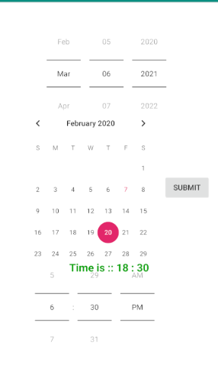 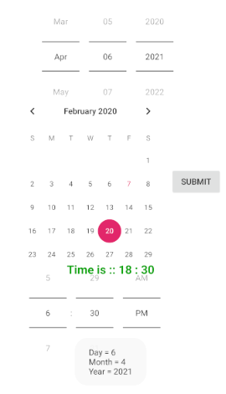 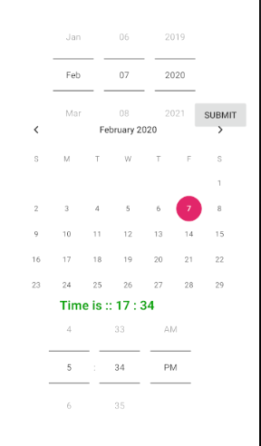 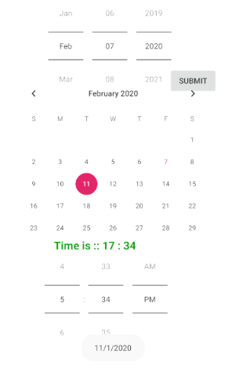

6. Display a digital clock. Use *switch view* to start and stop the clock.

Design

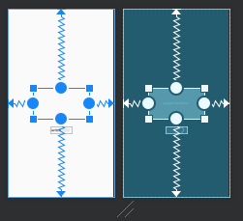

Source Code

Main_Activity.xml

<?xml version="1.0" encoding="utf-8"?>  
<androidx.constraintlayout.widget.ConstraintLayout xmlns:android="http://schemas.android.com/apk/res/android"  
 xmlns:app="http://schemas.android.com/apk/res-auto"  
 xmlns:tools="http://schemas.android.com/tools"  
 android:layout_width="match_parent"  
 android:layout_height="match_parent"  
 tools:context=".MainActivity">  
  
  
 <TextView  
 android:id="@+id/simpleText"  
 android:layout_width="217dp"  
 android:layout_height="120dp"  
 app:layout_constraintBottom_toBottomOf="parent"  
 app:layout_constraintEnd_toEndOf="parent"  
 app:layout_constraintStart_toStartOf="parent"  
 app:layout_constraintTop_toTopOf="parent" />  
  
 <TextClock  
 android:id="@+id/simpleTextClock"  
 android:layout_width="217dp"  
 android:layout_height="120dp"  
 android:format12Hour="hh:mm:ss a"  
 app:layout_constraintBottom_toBottomOf="parent"  
 app:layout_constraintEnd_toEndOf="parent"  
 app:layout_constraintStart_toStartOf="parent"  
 app:layout_constraintTop_toTopOf="parent"/>  
 <Switch  
 android:id="@+id/switch1"  
 android:layout_width="wrap_content"  
 android:layout_height="wrap_content"  
 android:layout_marginTop="212dp"  
 android:text="Switch"  
 app:layout_constraintBottom_toBottomOf="parent"  
 app:layout_constraintEnd_toEndOf="parent"  
 app:layout_constraintStart_toStartOf="parent"  
 app:layout_constraintTop_toTopOf="parent" />  
</androidx.constraintlayout.widget.ConstraintLayout>

MainActivity.java

package com.example.digitalclock;  
  
import androidx.appcompat.app.AppCompatActivity;  
  
import android.os.Bundle;  
import android.view.View;  
import android.widget.AnalogClock;  
import android.widget.DigitalClock;  
import android.widget.Switch;  
import android.widget.TextClock;  
import android.widget.TextView;  
import android.widget.Toast;  
  
public class MainActivity extends AppCompatActivity {  
  
 protected void onCreate(Bundle savedInstanceState) {  
  
 super.onCreate(savedInstanceState);  
 setContentView(R.layout.*activity_main*);  
  
 final Switch simpleSwitch1 = (Switch) findViewById(R.id.*switch1*);  
 final TextView t1 = (TextView) findViewById(R.id.*simpleText*);  
 final TextClock textClock = (TextClock) findViewById(R.id.*simpleTextClock*);  
 t1.setVisibility(View.*INVISIBLE*);  
 textClock.setVisibility(View.*VISIBLE*);  
  
 simpleSwitch1.setOnClickListener(new View.OnClickListener() {  
 @Override  
 public void onClick(View view) {  
 String statusSwitch1;  
 if (simpleSwitch1.isChecked()){  
 statusSwitch1 = simpleSwitch1.getTextOn().toString();  
// t1.setText(java.time.LocalTime.now().toString());  
 textClock.setVisibility(View.*VISIBLE*);  
 t1.setVisibility(View.*INVISIBLE*);  
 }  
 else {  
 statusSwitch1 = simpleSwitch1.getTextOff().toString();  
  
 textClock.setVisibility(View.*INVISIBLE*);  
 t1.setVisibility(View.*VISIBLE*);  
 t1.setText(textClock.getText());  
  
 }  
  
 }  
 });  
 }  
}

Output

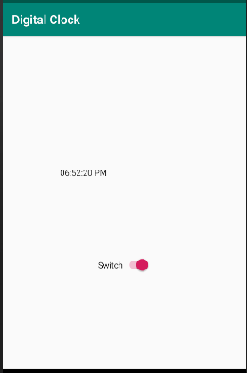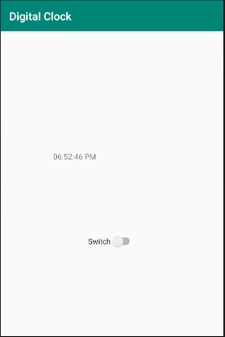

7. Create a ‘Form ‘using all the basic views (can use any layout). On Submitting the form, the details should be displayed in the same activity

Design

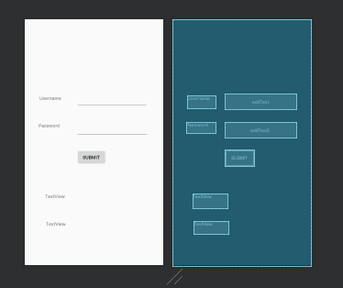

Source Code

Main_Activity.xml

<?xml version="1.0" encoding="utf-8"?>  
<androidx.constraintlayout.widget.ConstraintLayout xmlns:android="http://schemas.android.com/apk/res/android"  
 xmlns:app="http://schemas.android.com/apk/res-auto"  
 xmlns:tools="http://schemas.android.com/tools"  
 android:layout_width="match_parent"  
 android:layout_height="match_parent"  
 tools:context=".MainActivity">  
  
 <TextView  
 android:layout_width="84dp"  
 android:layout_height="39dp"  
 android:text="Username"  
 app:layout_constraintBottom_toBottomOf="parent"  
 app:layout_constraintHorizontal_bias="0.134"  
 app:layout_constraintLeft_toLeftOf="parent"  
 app:layout_constraintRight_toRightOf="parent"  
 app:layout_constraintTop_toTopOf="parent"  
 app:layout_constraintVertical_bias="0.325" />  
  
 <EditText  
 android:id="@+id/editText"  
 android:layout_width="212dp"  
 android:layout_height="45dp"  
 app:layout_constraintBottom_toBottomOf="parent"  
 app:layout_constraintHorizontal_bias="0.773"  
 app:layout_constraintLeft_toLeftOf="parent"  
 app:layout_constraintRight_toRightOf="parent"  
 app:layout_constraintTop_toTopOf="parent"  
 app:layout_constraintVertical_bias="0.319" />  
  
 <TextView  
 android:id="@+id/textView2"  
 android:layout_width="87dp"  
 android:layout_height="34dp"  
 android:text="Password"  
 app:layout_constraintBottom_toBottomOf="parent"  
 app:layout_constraintHorizontal_bias="0.126"  
 app:layout_constraintLeft_toLeftOf="parent"  
 app:layout_constraintRight_toRightOf="parent"  
 app:layout_constraintTop_toTopOf="parent"  
 app:layout_constraintVertical_bias="0.439" />  
  
 <EditText  
 android:id="@+id/editText2"  
 android:layout_width="wrap_content"  
 android:layout_height="wrap_content"  
 android:ems="10"  
 android:inputType="textPassword"  
 app:layout_constraintBottom_toBottomOf="parent"  
 app:layout_constraintHorizontal_bias="0.777"  
 app:layout_constraintLeft_toLeftOf="parent"  
 app:layout_constraintRight_toRightOf="parent"  
 app:layout_constraintTop_toTopOf="parent"  
 app:layout_constraintVertical_bias="0.446" />  
  
 <Button  
 android:id="@+id/button"  
 android:layout_width="wrap_content"  
 android:layout_height="wrap_content"  
 android:text="Submit"  
 app:layout_constraintBottom_toBottomOf="parent"  
 app:layout_constraintHorizontal_bias="0.476"  
 app:layout_constraintLeft_toLeftOf="parent"  
 app:layout_constraintRight_toRightOf="parent"  
 app:layout_constraintTop_toTopOf="parent"  
 app:layout_constraintVertical_bias="0.565" />  
  
 <TextView  
 android:id="@+id/textView3"  
 android:layout_width="103dp"  
 android:layout_height="37dp"  
 android:text="TextView"  
 app:layout_constraintBottom_toBottomOf="parent"  
 app:layout_constraintHorizontal_bias="0.204"  
 app:layout_constraintLeft_toLeftOf="parent"  
 app:layout_constraintRight_toRightOf="parent"  
 app:layout_constraintTop_toTopOf="parent"  
 app:layout_constraintVertical_bias="0.863" />  
  
 <TextView  
 android:id="@+id/textView4"  
 android:layout_width="102dp"  
 android:layout_height="43dp"  
 android:text="TextView"  
 app:layout_constraintBottom_toBottomOf="parent"  
 app:layout_constraintHorizontal_bias="0.196"  
 app:layout_constraintLeft_toLeftOf="parent"  
 app:layout_constraintRight_toRightOf="parent"  
 app:layout_constraintTop_toTopOf="parent"  
 app:layout_constraintVertical_bias="0.751" />  
  
</androidx.constraintlayout.widget.ConstraintLayout>

MainActivity.java

package com.example.myapplication;  
  
import androidx.appcompat.app.AppCompatActivity;  
  
import android.os.Bundle;  
import android.view.View;  
import android.widget.Button;  
import android.widget.EditText;  
import android.widget.TextView;  
  
public class MainActivity extends AppCompatActivity {  
 Button simpleButton1;  
 @Override  
 protected void onCreate(Bundle savedInstanceState) {  
 super.onCreate(savedInstanceState);  
 setContentView(R.layout.*activity_main*);  
 simpleButton1 = (Button) findViewById(R.id.*button*);  
 final EditText username = (EditText) findViewById(R.id.*editText*);  
 final EditText password = (EditText) findViewById(R.id.*editText2*);  
  
 simpleButton1.setOnClickListener(new View.OnClickListener() {  
 @Override  
 public void onClick(View view) {  
 String uname = username.getText().toString();  
 String pass = password.getText().toString();  
 final TextView u1 = (TextView) findViewById(R.id.*textView3*);  
 final TextView p1 = (TextView) findViewById(R.id.*textView4*);  
 u1.setText(uname);  
 p1.setText(pass);  
 }  
 });  
 }  
}

Output

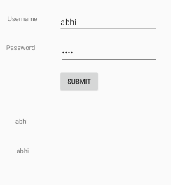

1. Create a calculator App.( only basic arithmetic is needed)

Design

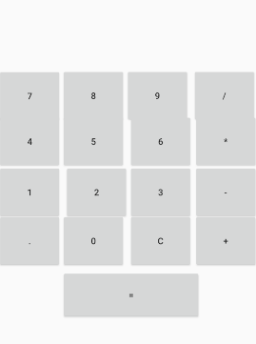

Main_Activity.xml

<?xml version="1.0" encoding="utf-8"?>  
<androidx.constraintlayout.widget.ConstraintLayout xmlns:android="http://schemas.android.com/apk/res/android"  
 xmlns:app="http://schemas.android.com/apk/res-auto"  
 xmlns:tools="http://schemas.android.com/tools"  
 android:layout_width="match_parent"  
 android:layout_height="match_parent"  
 tools:context=".MainActivity">  
  
 <TextView  
 android:id="@+id/txtScreen"  
 android:layout_width="409dp"  
 android:layout_height="120dp"  
 android:layout_alignParentTop="true"  
 android:layout_centerHorizontal="true"  
 android:gravity="right|center_vertical"  
 android:maxLength="16"  
 android:padding="10dp"  
 android:textAppearance="?android:attr/textAppearanceLarge"  
 android:textSize="30sp"  
 android:typeface="serif"  
 app:layout_constraintBottom_toBottomOf="parent"  
 app:layout_constraintStart_toStartOf="parent"  
 app:layout_constraintTop_toTopOf="parent"  
 app:layout_constraintVertical_bias="0.026" />  
  
 <Button  
 android:id="@+id/btnSeven"  
  
 android:text="7"  
 android:layout_width="101dp"  
 android:layout_height="86dp"  
 app:layout_constraintBottom_toBottomOf="parent"  
 app:layout_constraintEnd_toEndOf="parent"  
 app:layout_constraintHorizontal_bias="0.0"  
 app:layout_constraintStart_toStartOf="parent"  
 app:layout_constraintTop_toTopOf="parent"  
 app:layout_constraintVertical_bias="0.241" />  
  
 <Button  
 android:id="@+id/btnEight"  
 android:layout_width="101dp"  
 android:layout_height="86dp"  
 android:text="8"  
 app:layout_constraintBottom_toBottomOf="parent"  
 app:layout_constraintEnd_toEndOf="parent"  
 app:layout_constraintHorizontal_bias="0.325"  
 app:layout_constraintStart_toStartOf="parent"  
 app:layout_constraintTop_toTopOf="parent"  
 app:layout_constraintVertical_bias="0.24" />  
  
 <Button  
 android:id="@+id/btnNine"  
 android:layout_width="101dp"  
 android:layout_height="86dp"  
 android:text="9"  
 app:layout_constraintBottom_toBottomOf="parent"  
 app:layout_constraintEnd_toEndOf="parent"  
 app:layout_constraintHorizontal_bias="0.651"  
 app:layout_constraintStart_toStartOf="parent"  
 app:layout_constraintTop_toTopOf="parent"  
 app:layout_constraintVertical_bias="0.24" />  
  
 <Button  
 android:id="@+id/btnDivide"  
 android:layout_width="101dp"  
 android:layout_height="86dp"  
 android:text="/"  
 app:layout_constraintBottom_toBottomOf="parent"  
 app:layout_constraintEnd_toEndOf="parent"  
 app:layout_constraintHorizontal_bias="0.993"  
 app:layout_constraintStart_toStartOf="parent"  
 app:layout_constraintTop_toTopOf="parent"  
 app:layout_constraintVertical_bias="0.24" />  
  
 <Button  
 android:id="@+id/btnFour"  
 android:layout_width="101dp"  
 android:layout_height="86dp"  
 android:text="4"  
 app:layout_constraintBottom_toBottomOf="parent"  
 app:layout_constraintEnd_toEndOf="parent"  
 app:layout_constraintHorizontal_bias="0.0"  
 app:layout_constraintStart_toStartOf="parent"  
 app:layout_constraintTop_toTopOf="parent"  
 app:layout_constraintVertical_bias="0.392" />  
  
 <Button  
 android:id="@+id/btnFive"  
 android:layout_width="101dp"  
 android:layout_height="86dp"  
 android:text="5"  
 app:layout_constraintBottom_toBottomOf="parent"  
 app:layout_constraintEnd_toEndOf="parent"  
 app:layout_constraintHorizontal_bias="0.325"  
 app:layout_constraintStart_toStartOf="parent"  
 app:layout_constraintTop_toTopOf="parent"  
 app:layout_constraintVertical_bias="0.392" />  
  
 <Button  
 android:id="@+id/btnSix"  
 android:layout_width="101dp"  
 android:layout_height="86dp"  
 android:text="6"  
 app:layout_constraintBottom_toBottomOf="parent"  
 app:layout_constraintEnd_toEndOf="parent"  
 app:layout_constraintHorizontal_bias="0.667"  
 app:layout_constraintStart_toStartOf="parent"  
 app:layout_constraintTop_toTopOf="parent"  
 app:layout_constraintVertical_bias="0.392" />  
  
 <Button  
 android:id="@+id/btnMultiply"  
 android:layout_width="101dp"  
 android:layout_height="86dp"  
 android:text="*"  
 app:layout_constraintBottom_toBottomOf="parent"  
 app:layout_constraintEnd_toEndOf="parent"  
 app:layout_constraintHorizontal_bias="1.0"  
 app:layout_constraintStart_toStartOf="parent"  
 app:layout_constraintTop_toTopOf="parent"  
 app:layout_constraintVertical_bias="0.392" />  
  
 <Button  
 android:id="@+id/btnOne"  
 android:layout_width="101dp"  
 android:layout_height="86dp"  
 android:text="1"  
 app:layout_constraintBottom_toBottomOf="parent"  
 app:layout_constraintEnd_toEndOf="parent"  
 app:layout_constraintHorizontal_bias="0.0"  
 app:layout_constraintStart_toStartOf="parent"  
 app:layout_constraintTop_toTopOf="parent"  
 app:layout_constraintVertical_bias="0.561" />  
  
 <Button  
 android:id="@+id/btnTwo"  
 android:layout_width="101dp"  
 android:layout_height="86dp"  
 android:text="2"  
 app:layout_constraintBottom_toBottomOf="parent"  
 app:layout_constraintEnd_toEndOf="parent"  
 app:layout_constraintHorizontal_bias="0.341"  
 app:layout_constraintStart_toStartOf="parent"  
 app:layout_constraintTop_toTopOf="parent"  
 app:layout_constraintVertical_bias="0.561" />  
  
 <Button  
 android:id="@+id/btnThree"  
 android:layout_width="101dp"  
 android:layout_height="86dp"  
 android:text="3"  
 app:layout_constraintBottom_toBottomOf="parent"  
 app:layout_constraintEnd_toEndOf="parent"  
 app:layout_constraintHorizontal_bias="0.667"  
 app:layout_constraintStart_toStartOf="parent"  
 app:layout_constraintTop_toTopOf="parent"  
 app:layout_constraintVertical_bias="0.561" />  
  
 <Button  
 android:id="@+id/btnSubtract"  
 android:layout_width="101dp"  
 android:layout_height="86dp"  
 android:text="-"  
 app:layout_constraintBottom_toBottomOf="parent"  
 app:layout_constraintEnd_toEndOf="parent"  
 app:layout_constraintHorizontal_bias="1.0"  
 app:layout_constraintStart_toStartOf="parent"  
 app:layout_constraintTop_toTopOf="parent"  
 app:layout_constraintVertical_bias="0.561" />  
  
 <Button  
 android:id="@+id/btnDot"  
 android:layout_width="101dp"  
 android:layout_height="86dp"  
 android:text="."  
 app:layout_constraintBottom_toBottomOf="parent"  
 app:layout_constraintEnd_toEndOf="parent"  
 app:layout_constraintHorizontal_bias="0.0"  
 app:layout_constraintStart_toStartOf="parent"  
 app:layout_constraintTop_toTopOf="parent"  
 app:layout_constraintVertical_bias="0.722" />  
  
 <Button  
 android:id="@+id/btnZero"  
 android:layout_width="101dp"  
 android:layout_height="86dp"  
 android:text="0"  
 app:layout_constraintBottom_toBottomOf="parent"  
 app:layout_constraintEnd_toEndOf="parent"  
 app:layout_constraintHorizontal_bias="0.325"  
 app:layout_constraintStart_toStartOf="parent"  
 app:layout_constraintTop_toTopOf="parent"  
 app:layout_constraintVertical_bias="0.722" />  
  
 <Button  
 android:id="@+id/btnClear"  
 android:layout_width="101dp"  
 android:layout_height="86dp"  
 android:text="C"  
 app:layout_constraintBottom_toBottomOf="parent"  
 app:layout_constraintEnd_toEndOf="parent"  
 app:layout_constraintHorizontal_bias="0.667"  
 app:layout_constraintStart_toStartOf="parent"  
 app:layout_constraintTop_toTopOf="parent"  
 app:layout_constraintVertical_bias="0.722" />  
  
 <Button  
 android:id="@+id/btnAdd"  
 android:layout_width="101dp"  
 android:layout_height="86dp"  
 android:text="+"  
 app:layout_constraintBottom_toBottomOf="parent"  
 app:layout_constraintEnd_toEndOf="parent"  
 app:layout_constraintHorizontal_bias="1.0"  
 app:layout_constraintStart_toStartOf="parent"  
 app:layout_constraintTop_toTopOf="parent"  
 app:layout_constraintVertical_bias="0.722" />  
  
 <Button  
 android:id="@+id/btnEqual"  
 android:layout_width="220dp"  
 android:layout_height="78dp"  
 android:text="="  
 app:layout_constraintBottom_toBottomOf="parent"  
 app:layout_constraintEnd_toEndOf="parent"  
 app:layout_constraintHorizontal_bias="0.528"  
 app:layout_constraintStart_toStartOf="parent"  
 app:layout_constraintTop_toTopOf="parent"  
 app:layout_constraintVertical_bias="0.895" />  
</androidx.constraintlayout.widget.ConstraintLayout>

MainActivity.java

package com.example.calculator;  
  
import androidx.appcompat.app.AppCompatActivity;  
  
import android.os.Bundle;  
import android.view.View;  
import android.widget.Button;  
import android.widget.TextView;  
  
  
  
public class MainActivity extends AppCompatActivity {  
 public static double eval(final String str) {  
 return new Object() {  
 int pos = -1, ch;  
  
 void nextChar() {  
 ch = (++pos < str.length()) ? str.charAt(pos) : -1;  
 }  
  
 boolean eat(int charToEat) {  
 while (ch == ' ') nextChar();  
 if (ch == charToEat) {  
 nextChar();  
 return true;  
 }  
 return false;  
 }  
  
 double parse() {  
 nextChar();  
 double x = parseExpression();  
 if (pos < str.length()) throw new RuntimeException("Unexpected: " + (char)ch);  
 return x;  
 }  
  
 // Grammar:  
 // expression = term | expression `+` term | expression `-` term  
 // term = factor | term `*` factor | term `/` factor  
 // factor = `+` factor | `-` factor | `(` expression `)`  
 // | number | functionName factor | factor `^` factor  
  
 double parseExpression() {  
 double x = parseTerm();  
 for (;;) {  
 if (eat('+')) x += parseTerm(); // addition  
 else if (eat('-')) x -= parseTerm(); // subtraction  
 else return x;  
 }  
 }  
  
 double parseTerm() {  
 double x = parseFactor();  
 for (;;) {  
 if (eat('*')) x *= parseFactor(); // multiplication  
 else if (eat('/')) x /= parseFactor(); // division  
 else return x;  
 }  
 }  
  
 double parseFactor() {  
 if (eat('+')) return parseFactor(); // unary plus  
 if (eat('-')) return -parseFactor(); // unary minus  
  
 double x;  
 int startPos = this.pos;  
 if (eat('(')) { // parentheses  
 x = parseExpression();  
 eat(')');  
 } else if ((ch >= '0' && ch <= '9') || ch == '.') { // numbers  
 while ((ch >= '0' && ch <= '9') || ch == '.') nextChar();  
 x = Double.*parseDouble*(str.substring(startPos, this.pos));  
 } else if (ch >= 'a' && ch <= 'z') { // functions  
 while (ch >= 'a' && ch <= 'z') nextChar();  
 String func = str.substring(startPos, this.pos);  
 x = parseFactor();  
 if (func.equals("sqrt")) x = Math.*sqrt*(x);  
 else if (func.equals("sin")) x = Math.*sin*(Math.*toRadians*(x));  
 else if (func.equals("cos")) x = Math.*cos*(Math.*toRadians*(x));  
 else if (func.equals("tan")) x = Math.*tan*(Math.*toRadians*(x));  
 else throw new RuntimeException("Unknown function: " + func);  
 } else {  
 throw new RuntimeException("Unexpected: " + (char)ch);  
 }  
  
 if (eat('^')) x = Math.*pow*(x, parseFactor()); // exponentiation  
  
 return x;  
 }  
 }.parse();  
 }  
  
 private int[] numericButtons = {R.id.*btnZero*, R.id.*btnOne*, R.id.*btnTwo*, R.id.*btnThree*, R.id.*btnFour*, R.id.*btnFive*, R.id.*btnSix*, R.id.*btnSeven*, R.id.*btnEight*, R.id.*btnNine*};  
 private int[] operatorButtons = {R.id.*btnAdd*, R.id.*btnSubtract*, R.id.*btnMultiply*, R.id.*btnDivide*};  
 private TextView txtScreen;  
 private boolean lastNumeric;  
 private boolean stateError;  
 private boolean lastDot;  
  
 @Override  
 protected void onCreate(Bundle savedInstanceState) {  
 super.onCreate(savedInstanceState);  
 setContentView(R.layout.*activity_main*);  
 this.txtScreen = (TextView) findViewById(R.id.*txtScreen*);  
 setNumericOnClickListener();  
 setOperatorOnClickListener();  
 }  
  
 private void setNumericOnClickListener() {  
 View.OnClickListener listener = new View.OnClickListener() {  
 @Override  
 public void onClick(View v) {  
 Button button = (Button) v;  
 if (stateError) {  
 txtScreen.setText(button.getText());  
 stateError = false;  
 } else {  
 txtScreen.append(button.getText());  
 }  
 lastNumeric = true;  
 }  
 };  
 for (int id : numericButtons) {  
 findViewById(id).setOnClickListener(listener);  
 }  
 }  
  
 private void setOperatorOnClickListener() {  
 View.OnClickListener listener = new View.OnClickListener() {  
 @Override  
 public void onClick(View v) {  
 if (lastNumeric && !stateError) {  
 Button button = (Button) v;  
 txtScreen.append(button.getText());  
 lastNumeric = false;  
 lastDot = false;  
 }  
 }  
 };  
  
 for (int id : operatorButtons) {  
 findViewById(id).setOnClickListener(listener);  
 }  
 findViewById(R.id.*btnDot*).setOnClickListener(new View.OnClickListener() {  
 @Override  
 public void onClick(View v) {  
 if (lastNumeric && !stateError && !lastDot) {  
 txtScreen.append(".");  
 lastNumeric = false;  
 lastDot = true;  
 }  
 }  
 });  
 findViewById(R.id.*btnClear*).setOnClickListener(new View.OnClickListener() {  
 @Override  
 public void onClick(View v) {  
 txtScreen.setText(""); // Clear the screen  
 // Reset all the states and flags  
 lastNumeric = false;  
 stateError = false;  
 lastDot = false;  
 }  
 });  
 findViewById(R.id.*btnEqual*).setOnClickListener(new View.OnClickListener() {  
 @Override  
 public void onClick(View v) {  
 onEqual();  
 }  
 });  
 }  
  
 private void onEqual() {  
   
 if (lastNumeric && !stateError) {  
  
 String txt = txtScreen.getText().toString();  
  
 try {  
  
 double result = *eval*(txt);  
 txtScreen.setText(Double.*toString*(result));  
 lastDot = true;   
 } catch (ArithmeticException ex) {  
 // Display an error message  
 txtScreen.setText("Error");  
 stateError = true;  
 lastNumeric = false;  
 }  
 }  
 }  
}

Output

